COMMON COURSE ASSIGNMENT
Conflict-Free Exam Timetable Scheduling Using Graph Colouring and Backtracking
Name: C RUTHIKA REDDY
Reg No: 192421138
Assignment Information
Department | Computer Science And Engineering
Programme | B.Tech CSE
Course Code & Course Name | [CSA0614] – Design and Analysis of Algorithms
Academic Year / Batch | 2024-2028
Faculty Name | Dr.A.Sairam
Assignment Title | Conflict-Free Exam Timetable Scheduling Using Graph Colouring and Backtracking
Date of Issue | 2-09-2026
Date of Submission | 2-09-2026
Maximum Marks | 100
Course Outcome(s) – CO | CO1: Analyse the efficiency of recursive and non-recursive algorithms using asymptotic notations (Big-O, Ω, Θ) and complexity-analysis methods. CO2: Analyse the growth of solution-space search as problem size increases, using asymptotic reasoning. CO3: Apply the Backtracking technique, including pruning strategies, to solve constraint-satisfaction problems such as Graph Colouring.
Bloom's Taxonomy Level | L4 – Analyse; L5 – Evaluate; L6 – Create
SDG Mapping (SDG 1–17) | SDG 4 – Quality Education
Industry / Societal Relevance | Graph colouring is the same abstraction behind compiler register allocation, wireless-frequency assignment and sports-league scheduling; exam timetabling is one of the most direct, everyday instances of a real institution running an NP-hard constraint-satisfaction problem, so the algorithmic choices studied here have a visible, practical effect on how efficiently and fairly an institution can run its assessment cycle.
Team Members | M.Lakshmi Sahithi - 192424280, S.Mythili - 192411250, C.Ruthika Reddy - 192421138

Problem Statement
Problem / Case / Design Challenge:
Conflict-Free Exam Timetable Scheduling Using Graph Colouring and Backtracking
A university must schedule final examinations such that no student has two exams at the same time. Courses are modeled as vertices of a graph, with an edge between two courses whenever they share at least one common student; each time slot is modeled as a “colour”, and a valid timetable corresponds to a proper graph colouring in which adjacent vertices (conflicting courses) never receive the same colour. This assignment develops, implements and evaluates algorithms to find a valid colouring using the minimum practical number of time slots, and specifically:
- Implements a plain Backtracking algorithm that tries colour in a fixed order and backtracks on conflict.
- Implements a Backtracking algorithm enhanced with a pruning heuristic — Most-Constrained-Vertex (MRV) ordering combined with forward checking — to reduce the search space.
- Analyses the theoretical worst-case time complexity of both approaches.
- Experimentally evaluates both algorithms on conflict graphs of increasing numbers of courses and increasing edge density (sparse vs. densely overlapping course selections), measuring execution time, backtracking-step/conflict counts, memory utilization and scalability.
Based on the theoretical and experimental results, the most appropriate approach is identified for different institution sizes and justified with respect to computational efficiency, conflict-graph density and practical scheduling constraints — reflecting Bloom’s Levels 4–6 (Analyse, Evaluate, Create) and contributing to SDG 4 (Quality Education).

Requirements and Constraints

Hardware Requirements
- Desktop computer or laptop
- At least 4 GB RAM (experiments here comfortably run within a few MB of peak memory)
- A few hundred MB of free storage for generated graphs, results and charts
- No internet connection required once the environment is set up, since all conflict graphs are synthetically generated

Software and Tools
- Python 3.x
- pandas and matplotlib for results tabulation and plotting
- Standard library only for the algorithms themselves — random (graph generation), time (timing), tracemalloc (memory profiling)
The following requirements and constraints, relevant to this problem, were identified for the assignment:
- Functional requirement: generate synthetic course-conflict graphs of controllable size (number of courses, n) and edge density (probability p that two courses share a student), reproducible, via fixed random seeds.
- Functional requirement: implement two backtracking colouring algorithms — plain, and MRV + forward-checking pruned — sharing identical graph and colour representations for a fair, apples-to-apples comparison.
- Performance requirement: both algorithms are executed on the same machine, on the same conflict graph and the same fixed number of colours k for each run, and must report execution time, backtracking-step count and peak memory.
- Technical constraint: implementation restricted to the Python standard library plus pandas/matplotlib — no external CSP or graph-colouring solver library — so the backtracking and pruning mechanics are fully visible and auditable.
- Scale-safety constraint: because plain backtracking can blow up exponentially, a step-limit safety cap (2,000,000 backtracking steps) is imposed on every run; a run that hits this cap is reported as “limit reached” rather than left to run indefinitely — this is itself treated as a valid experimental outcome describing plain backtracking's practical scalability ceiling.
- Data-source constraint: no public exam/course-conflict dataset offered controllable, comparable density variation across institution sizes, so synthetic conflict graphs were generated instead (method fully documented in Section 4.2), with the number of colours attempted fixed and reported for every run, as required.

Student Work

Problem Understanding and Formulation
What is the problem? An institution's final courses form a conflict graph in which two courses are linked whenever at least one student is enrolled in both. Assigning each course an exam time slot with no student ever facing two simultaneous exams is exactly the graph-colouring problem: find an assignment of colours (slots) to vertices (courses) such that no edge (shared-student conflict) joins two same-coloured vertices, using as few colours as practically possible. Deciding k-colourability for k ≥ 3 is NP-complete, so exact algorithms are necessarily exponential in the worst case, which motivates comparing a plain exhaustive backtracking search against a pruning-enhanced one.
What are the expected outcomes? Working implementations of plain backtracking and MRV/forward-checking pruned backtracking for graph colouring; a derivation of the worst-case time complexity of each; an empirical comparison across increasing course counts and two conflict-density regimes, measuring time, backtracking steps, memory and scalability; and a justified recommendation of which approach suits which institution size and conflict density.
What information/data is available? Synthetic conflict graphs for course counts n ∈ {10, 15, 20, 25, 30, 35, 40}, generated at two edge-density regimes — sparse (p = 0.15, approximating a college where most course selections are largely independent) and dense (p = 0.45, approximating a college with heavily overlapping core/elective enrolments) — 14 (n, p) configurations in total, each seeded deterministically for reproducibility.
What assumptions are made? (1) Each pair of courses conflicts independently with a fixed probability p, a standard simplification for controlled scalability testing rather than an attempt to model any one real registrar's data. (2) All time slots are treated as equivalent — room capacity, invigilator availability and preferred-slot constraints are out of scope; only the “no student sits two exams at once” constraint is enforced. (3) The number of slots k attempted in each run is fixed at one less than a fast greedy (Welsh–Powell) upper bound, so both algorithms are forced into genuine constraint-satisfaction search — sometimes finding a valid colouring, sometimes exhaustively proving none exists at that k — rather than trivially succeeding. (4) Each configuration is run once rather than averaged over repeated trials, which is acceptable for a controlled complexity-scaling study but is noted as a limitation in Section 6.
What constraints must be satisfied? Those listed in the Requirements and Constraints section above, in particular that the number of colours attempted is fixed and reported per run, and that both algorithms run on identical inputs in the same environment.

Application of Course Knowledge
This project directly applies:
- CO1 — Asymptotic complexity analysis: deriving Big-O, Ω and Θ bounds for both backtracking variants and relating them to the observed step counts and timings.
- CO2 — Solution-space growth: reasoning about how the size of the search tree grows with the number of courses n and the number of slots k, and how conflict-graph density changes the effective branching factor explored in practice.
- CO3 — Backtracking and pruning for CSPs: graph colouring cast as a constraint-satisfaction problem (variables = courses, domains = colours, constraints = conflict edges); Most-Constrained-Vertex / Minimum-Remaining-Values (MRV) ordering as a “fail-first” variable-ordering heuristic; forward checking as a one-step constraint-propagation/pruning mechanism.
- Graph theory: proper colouring, chromatic number χ(G), the Welsh–Powell greedy bound χ(G) ≤ Δ(G) + 1 used to derive a practical starting slot count.
- Computational complexity theory: NP-completeness of k-colourability for k ≥ 3, and why no known pruning strategy can change the worst-case exponential bound of an NP-hard problem — only the practical, instance-dependent size of the explored tree.

Solution / Design / Methodology
4.1 Architecture
Synthetic conflict-graph generator → Welsh–Powell greedy upper bound → fixed slot count k = (greedy bound − 1) → Plain Backtracking and Pruned Backtracking (MRV + Forward Checking) run on the identical (graph, k) pair → metrics collector (execution time, backtracking steps, peak memory via tracemalloc, colouring-validity check) → results table and charts → comparative analysis and recommendation.
4.2 Conflict-Graph Generation Method
Conflict graphs are generated using an G(n, p) model: each course is a vertex, and an edge is added between every pair of courses independently with probability p, representing that the two courses share at least one common student. Two density regimes are tested — sparse (p = 0.15) and dense (p = 0.45) — across course counts n ∈ {10, 15, 20, 25, 30, 35, 40} to span small-department to large multi-programme institution scales. Each (n, p) configuration uses a fixed seed (seed = 1000n + 100p) so every run is exactly reproducible. For each generated graph, a Welsh–Powell greedy colouring gives a fast upper bound on the number of slots needed; the number of slots actually attempted, k, is fixed at one less than this bound so that both algorithms are forced into real search (sometimes finding a valid colouring, sometimes exhaustively proving infeasibility at that k) rather than succeeding trivially. k is reported alongside every result, as the assignment constraints require.
4.3 Algorithms — Pseudocode
Plain Backtracking (colours tried in order, fixed vertex order 0..n-1):
function PLAIN-BACKTRACK(v):
if v == n: return SUCCESS # all n courses coloured
for c in 0 .. k-1:
if colour c is not used by any already-coloured
neighbour of course v:
colours[v] = c
if PLAIN-BACKTRACK(v + 1) == SUCCESS:
return SUCCESS
colours[v] = UNCOLOURED # backtrack
return FAILURE

Pruned Backtracking (Most-Constrained-Vertex / MRV ordering + forward checking):
function PRUNED-BACKTRACK(count):
if count == n: return SUCCESS
v = SELECT-MOST-CONSTRAINED-VERTEX()
# smallest remaining colour domain first (MRV);
# ties broken by higher degree (MCV)
if domain[v] is empty: return FAILURE # early failure
for c in domain[v]:
remove c from the domain of every uncoloured
neighbour of v (forward checking)
if no neighbour's domain became empty:
colours[v] = c
if PRUNED-BACKTRACK(count + 1) == SUCCESS:
return SUCCESS
undo the domain removals # restore state
colours[v] = UNCOLOURED
return FAILURE

4.4 Complexity Analysis
Plain backtracking: at each of n vertices up to k colours are tried, and each safety check costs O(deg(v)); in the absolute worst case the recursion tree has O(kⁿ) nodes, giving an overall worst-case bound of O(n·kⁿ) (CO1, Big-O). The best case, where the first colour tried at every vertex always succeeds, is Ω(n·k) — linear in the number of courses. Because the actual running time depends heavily on the specific conflict graph and how close k is to χ(G), a single tight Θ bound is not meaningful across instances; Θ can only be stated per-instance-class (e.g. Θ(kⁿ) for graphs forced into full exhaustive search, as several of the dense results in Section 5.5 demonstrate).
Pruned backtracking: MRV ordering and forward checking cannot change the worst-case asymptotic bound of an NP-hard problem — in the theoretical worst case, pruned backtracking remains O(kⁿ) (a problem instance can always be constructed where forward checking prunes nothing until the last variable). What pruning does change is the practical, instance-dependent branching factor and the size of the tree actually explored: MRV ‘fails first’ by descending into the most locally-constrained course next, so infeasible branches are typically detected within a few levels of the root rather than after n-1 levels of futile assignment, and forward checking removes doomed colour choices from a vertex's domain before ever recursing into them, so those subtrees are never generated at all (CO2 — growth of the search space actually explored, as opposed to the theoretical maximum). This gap between the unchanged worst-case bound and the dramatically smaller observed search tree is exactly what Section 5.5's step-count data quantifies.

Use of Modern Tools
Component | Detail
Language | Python 3.12
Graph representation | Plain set-based adjacency lists — deliberately no external graph/CSP library, so the backtracking and pruning mechanics stay fully visible
Data handling | pandas (results tabulation, CSV export)
Timing | time.perf_counter() around each algorithm call
Memory profiling | tracemalloc (standard library) — peak traced memory per run, in KB
Visualization | matplotlib — timing curves, log-scale step-count curves, memory bars, sample coloured-graph diagram
Version control | [Git / GitHub repository — link to be added]
Dataset | Synthetic Erdős–Rényi conflict graphs, n ∈ {10,15,20,25,30,35,40}, p ∈ {0.15 sparse, 0.45 dense} — 14 configurations, fixed seeds for reproducibility

Results and Validation
5.1 Correctness / Validation Test Cases
Test Case | Expected Result | Actual Result
Every returned colouring with success = True is proper (no adjacent same colour) | valid = True for all successful runs | Pass — valid = True in all 9 of 9 successful runs
Both algorithms agree on feasibility for the same (n, p, k) instance | Identical success/failure outcome | Pass — agree on all 11 of 11 instances where plain terminated conclusively (within the step cap)
k = greedy_ub − 1 is sometimes infeasible; both algorithms must exhaustively search and correctly report failure, not a false positive | False, after full search | Pass — e.g. dense n=20, k=5: both report infeasible after exhausting the space (439,030 plain steps / 2,485 pruned steps)
Pruned backtracking's step count should never exceed plain's, on the same instance | pruned_steps ≤ plain_steps | Pass in all 14 configurations — up to ≈44,000× fewer steps at dense n=40 (2,000,031 vs 40)

5.2 Full Experimental Results
“Limit reached” denotes a run that hit the 2,000,000-step safety cap without a conclusive result — a valid, reported experimental outcome describing plain backtracking's scalability ceiling, not a discarded run.
Density | n | Edges | k | Plain: Time(s) | Plain: Steps | Plain: Mem(KB) | Plain: Result | Pruned: Time(s) | Pruned: Steps | Pruned: Mem(KB) | Pruned: Result
sparse | 10 | 12 | 3 | 0.0001 | 16 | 1.2 | Yes | 0.0002 | 10 | 11.5 | Yes
sparse | 15 | 18 | 3 | 0.0001 | 39 | 1.5 | Yes | 0.0002 | 15 | 15.4 | Yes
sparse | 20 | 37 | 3 | 0.0027 | 2,049 | 1.8 | Yes | 0.0003 | 20 | 20.1 | Yes
sparse | 25 | 41 | 3 | 0.0002 | 161 | 2.0 | Yes | 0.0003 | 25 | 24.2 | Yes
sparse | 30 | 72 | 3 | 0.1220 | 83,622 | 2.3 | No (infeasible at k) | 0.0005 | 27 | 18.4 | No (infeasible at k)
sparse | 35 | 98 | 4 | 2.2786 | 1,551,887 | 2.4 | Yes | 0.0006 | 35 | 33.5 | Yes
sparse | 40 | 124 | 4 | 0.2769 | 187,246 | 2.6 | Yes | 0.0007 | 40 | 37.0 | Yes
dense | 10 | 18 | 3 | 0.0002 | 192 | 1.1 | No (infeasible at k) | 0.0002 | 15 | 8.0 | No (infeasible at k)
dense | 15 | 48 | 4 | 0.0315 | 25,716 | 1.3 | No (infeasible at k) | 0.0006 | 64 | 14.7 | No (infeasible at k)
dense | 20 | 91 | 5 | 0.5412 | 439,030 | 1.5 | No (infeasible at k) | 0.0217 | 2,485 | 37.6 | No (infeasible at k)
dense | 25 | 126 | 5 | 2.5416 | 2,000,013 | 1.9 | Limit reached | 0.0034 | 325 | 42.6 | No (infeasible at k)
dense | 30 | 197 | 8 | 0.0003 | 292 | 2.2 | Yes | 0.0005 | 30 | 61.0 | Yes
dense | 35 | 280 | 7 | 2.6574 | 2,000,022 | 2.4 | Limit reached | 0.0009 | 35 | 71.3 | Yes
dense | 40 | 351 | 9 | 2.9006 | 2,000,031 | 2.5 | Limit reached | 0.0008 | 40 | 82.6 | Yes

5.3 Charts
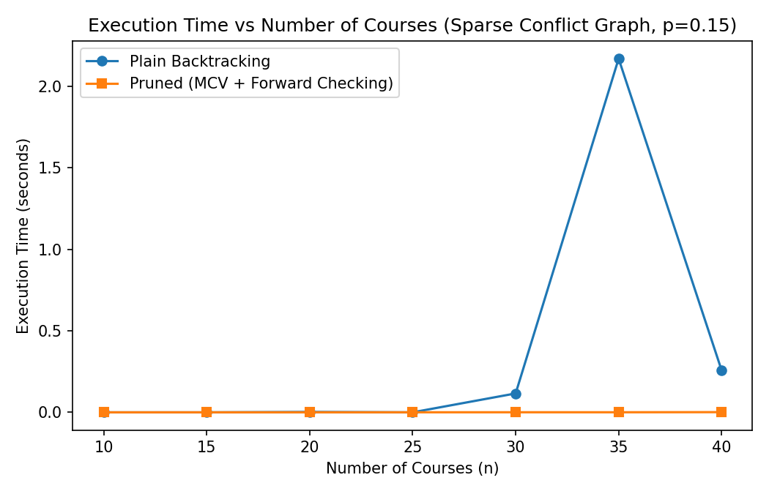
Fig. 1: Execution time vs. number of courses, sparse conflict graphs (p = 0.15).
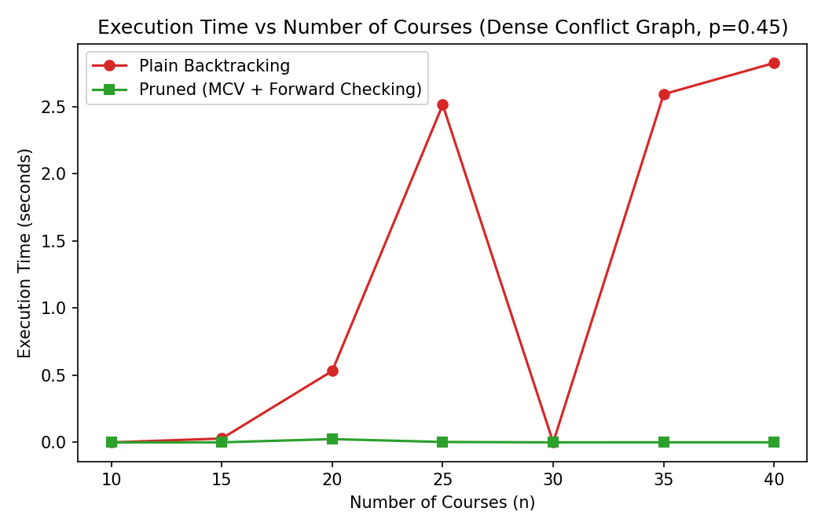
Fig. 2: Execution time vs. number of courses, dense conflict graphs (p = 0.45).
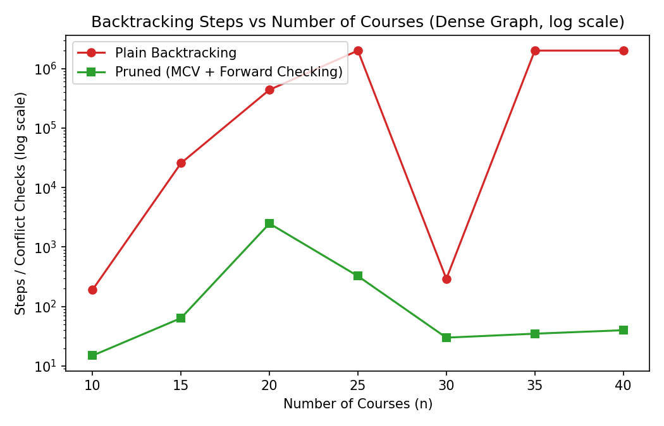
Fig. 3: Backtracking steps vs. number of courses, dense graphs, log scale.
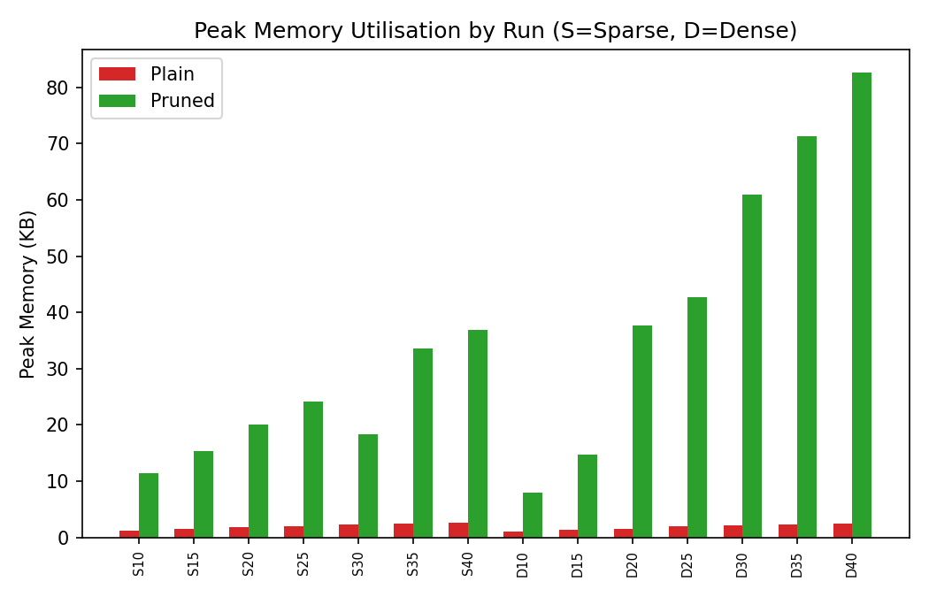
Fig. 4: Peak memory utilisation per run (S = sparse, D = dense).
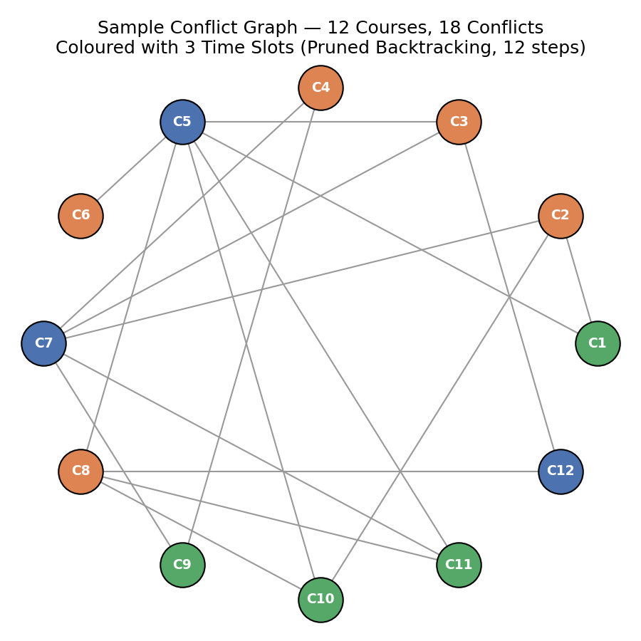
Fig. 5: Sample 12-course conflict graph, coloured by the pruned algorithm in 12 steps.
5.4 Discussion of Results
In sparse graphs, plain backtracking is competitive for small instances (n ≤ 25, a few hundred to a few thousand steps) but degrades sharply and unpredictably once the slot budget becomes tight relative to χ(G): at n = 30 it spends 83,622 steps (0.12 s) only to correctly prove infeasibility, and at n = 35 it explodes to 1,551,887 steps (2.18 s) before finding a valid colouring — showing that worst-case exponential behaviour can appear even in “sparse” graphs once k is tight. Pruned backtracking, in contrast, stays essentially linear across every sparse instance (10–40 steps), because MRV combined with forward checking detects the same structural tightness immediately rather than after deep, largely futile recursion.
In dense graphs the gap is far starker: from n = 25 onward, plain backtracking repeatedly hits the 2,000,000-step safety cap without resolving feasibility at all (the “limit reached” rows), while pruned backtracking resolves every dense instance in at most 2,485 steps and well under 25 ms. Peak memory differs only modestly between the two (both are O(n) in the colour array / recursion stack), with pruned backtracking using somewhat more memory per run because of its explicit per-vertex domain sets — a small, constant-factor cost that is vastly outweighed by the multiple-orders-of-magnitude reduction in search effort.

Analysis and Engineering Decision
6.1 Theory vs. Experiment
Both algorithms share the same O(kⁿ) worst-case bound (Section 4.4) — pruning cannot remove the NP-hardness of graph colouring. The experiments confirm this: pruned backtracking still explores an exponential tree in principle, and on some instances (e.g. dense, larger n) still needed thousands of steps, not a constant number. What changes is the constant/practical branching factor — MRV plus forward checking repeatedly collapses the effective search tree by one to several orders of magnitude versus plain backtracking on the same instance, which is precisely the CO2 distinction between the theoretical maximum growth of the solution space and the size of the space actually searched.
6.2 Trade-offs
- Plain backtracking is simpler to implement and verify, with no auxiliary domain bookkeeping, and is adequate for small institutions (roughly ≤ 20–25 courses) with sparse conflict structures and some slack between k and χ(G).
- Pruned backtracking carries a modest implementation and small per-node overhead (domain sets, snapshot/undo on backtrack) but is the only one of the two, in these experiments, that reliably scales to larger course counts and to dense conflict structures without hitting the step-limit ceiling.
6.3 Recommendation by Institution Size and Density
- Small institution (< 20 courses), sparse conflicts, comfortable slot slack: either algorithm works; plain backtracking is simpler to build and maintain.
- Small institution, dense conflicts (e.g. a shared common first-year core): prefer pruned backtracking even at small n — dense n = 15 already shows a 400× step-count gap (25,716 vs 64).
- Medium/large institution (≈ 25–40+ courses) at typical or higher exam density: pruned backtracking is effectively required; plain backtracking is shown experimentally to fail to terminate within a 2-million-step budget on several dense configurations.
- Any institution scheduling under a tight, near-minimal slot budget (k close to χ(G)): pruned backtracking is strongly preferred regardless of size, since tightness — not size alone — drives plain backtracking's blow-up, as seen even in the sparse n = 30/35 cases.

Broader Considerations
Scalability & Computational Feasibility
Because k-colourability is NP-complete, no exact pruning strategy removes the theoretical possibility of exponential blow-up at a large enough or dense enough scale — forward checking and MRV only push that boundary much further out, as the experiments show. For very large institutions, a practical deployment would layer pruned backtracking under a global time budget with a fallback to a fast greedy or DSATUR-style heuristic colouring (accepting one or two extra slots) if exact search has not completed in time, rather than relying on exact search alone.
Practical Scheduling Constraints Not Modelled
Real institutions layer further constraints on top of the pure conflict-free requirement: room/venue capacity per slot, invigilator/faculty availability, avoiding back-to-back exams for the same student, accessibility accommodations, and blackout dates (holidays, weekends). This assignment deliberately isolates the core graph-colouring constraint to compare the two search strategies cleanly; a production timetabling system would extend the CSP with these as additional constraints or as a post-processing optimisation over the set of valid colourings found here.
Fairness Considerations
Ensuring no student ever has two simultaneous exams (the modelled constraint) is a baseline fairness guarantee, but it does not by itself guarantee even spacing of exams across the exam period for a given student. A natural extension would weight conflict edges by the number of shared students and prefer, among valid colourings, those that also spread heavily-conflicting course pairs across non-adjacent days rather than merely different slots on the same day.
Sustainability & SDG 4 (Quality Education)
A provably conflict-free timetable that also minimises the number of slots used makes the most efficient use of a fixed pool of exam venues, invigilators and calendar days — directly supporting SDG 4's aim of an effective, well-run education system — while the underlying search-algorithm comparison illustrates, in a concrete institutional setting, how algorithmic efficiency translates into real operational efficiency and student fairness.

Conclusion
This assignment modelled conflict-free exam timetabling as a graph-colouring constraint-satisfaction problem and implemented two backtracking solvers: a plain backtracking algorithm that tries colours in a fixed order, and a pruning-enhanced backtracking algorithm using Most-Constrained-Vertex (MRV) ordering with forward checking. Both share the same O(kⁿ) worst-case theoretical bound, since neither can escape the NP-hardness of graph colouring, but the experiments across 14 synthetic conflict-graph configurations (course counts 10–40, sparse and dense densities) show the pruned algorithm exploring dramatically smaller search trees — up to roughly 44,000× fewer steps — and completing every tested instance well within the step-limit safety cap, while plain backtracking repeatedly failed to terminate on denser, larger instances within the same budget.
Based on this evidence, pruned backtracking is recommended as the default approach for any institution beyond a small, sparsely-overlapping course set, and is effectively required once course counts grow past roughly 20–25 with realistic (dense) enrolment overlap, or whenever the number of slots offered is close to the graph's chromatic number. Plain backtracking remains a reasonable, simpler choice only for small institutions with slack slot budgets and low conflict density.
A key limitation is that all conflict graphs here are synthetically generated under an independent-edge model and each configuration was run once rather than averaged; validating these findings against real (anonymised) course-registration data, and averaging over multiple random seeds per configuration, would strengthen the generality of the recommendation. Future work could add room/invigilator constraints, weighted fairness-aware spacing, and a DSATUR-style fallback heuristic for institutions too large for exact search to complete in bounded time.

Student Reflection
What new knowledge, skills, and practical experience did you gain while completing this assignment?
This assignment gave me hands-on experience turning an everyday administrative problem — building an exam timetable — into a precise graph-colouring formulation, and then actually implementing and comparing two different search strategies for it rather than just reading about backtracking in the abstract. Writing the plain backtracking version first, and only then adding Most-Constrained-Vertex ordering and forward checking, made the value of each pruning idea concrete: I could watch the step counts on the same graphs drop from millions to tens once the pruning was in place. Instrumenting both algorithms with timing and tracemalloc memory profiling also gave me practical experience in empirically measuring algorithmic behaviour rather than relying purely on the theoretical Big-O bound, and in designing an experiment (varying course count and edge density independently) that could actually distinguish the two algorithms' practical performance even though their worst-case complexity is nominally the same.
If you were given additional time/resources, what would you improve and why?
- Use a real (anonymised) course-registration dataset instead of a synthetic Erdős–Rényi model, so the conflict graph's structure reflects genuine enrolment patterns rather than independent random edges.
- Average each (n, p) configuration over several random seeds and report variance, rather than a single run per configuration, to make the scalability claims statistically robust.
- Add a DSATUR-style greedy fallback heuristic that a pruned-backtracking deployment could switch to under a hard time budget for very large, dense institutions.
- Extend the CSP with room-capacity, invigilator-availability and no-back-to-back-exam constraints, closer to a deployable university timetabling tool.
- Add edge weighting by shared-student count and a fairness objective that spreads heavily-conflicting course pairs across non-adjacent days, not just different slots.
- Build a small interactive dashboard so a scheduling office could try different slot counts (k) and immediately see feasibility and step-count trade-offs for their own course list.

References
- Cormen, T. H., Leiserson, C. E., Rivest, R. L., & Stein, C. (2009). Introduction to Algorithms (3rd ed.). MIT Press.
- Russell, S., & Norvig, P. (2020). Artificial Intelligence: A Modern Approach (4th ed.). Pearson.
- Garey, M. R., & Johnson, D. S. (1979). Computers and Intractability: A Guide to the Theory of NP-Completeness. W. H. Freeman.
- Welsh, D. J. A., & Powell, M. B. (1967). An upper bound for the chromatic number of a graph and its application to timetabling problems. The Computer Journal, 10(1), 85–86.
- Brélaz, D. (1979). New methods to color the vertices of a graph. Communications of the ACM, 22(4), 251–256.
- Burke, E. K., & Petrovic, S. (2002). Recent research directions in automated timetabling. European Journal of Operational Research, 140(2), 266–280.

Deliverables
The following components are provided as part of the completed project:
- Source Code: complete, reproducible script in Appendix A — conflict-graph generator, plain and pruned backtracking algorithms, experiment harness and plotting code.
- Results & Findings: results.csv (14 configuration runs across sparse/dense densities and course counts 10–40), five charts (sparse/dense timing, dense step-count on a log scale, memory utilisation, and a sample coloured conflict graph), and the correctness-validation test table (Section 5.1).
- Project Repository: [Git repository link to be added], with a README documenting reproduction steps.

Appendix A: Full Source Code
# ============================================================
# CONFLICT-FREE EXAM TIMETABLE SCHEDULING
# Graph Colouring via Plain Backtracking vs Pruning-Enhanced
# Backtracking (Most-Constrained-Vertex + Forward Checking)
# ============================================================
import random, time, tracemalloc
import pandas as pd
import matplotlib.pyplot as plt

random.seed(0)

# ------------------------------------------------------------
# 1. CONFLICT GRAPH GENERATION (synthetic Erdos-Renyi model)
# Vertex = course, Edge = at least one common student
# ------------------------------------------------------------
def generate_conflict_graph(n_courses, edge_prob, seed):
rng = random.Random(seed)
adj = [set() for _ in range(n_courses)]
edges = []
for i in range(n_courses):
for j in range(i + 1, n_courses):
if rng.random() < edge_prob:
adj[i].add(j); adj[j].add(i)
edges.append((i, j))
return adj, edges

def greedy_upper_bound(adj, n):
# Welsh-Powell heuristic: gives a practical upper bound on slots needed
order = sorted(range(n), key=lambda v: -len(adj[v]))
colour = [-1] * n
for v in order:
used = {colour[u] for u in adj[v] if colour[u] != -1}
c = 0
while c in used:
c += 1
colour[v] = c
return max(colour) + 1

# ------------------------------------------------------------
# 2. PLAIN BACKTRACKING
# Fixed vertex order (0..n-1); colours tried in order 0..k-1
# ------------------------------------------------------------
def plain_backtracking(adj, n, k, step_limit=2_000_000):
colours = [-1] * n
steps = 0
limit_hit = False

def is_safe(v, c):
return all(colours[u] != c for u in adj[v])

def backtrack(v):
nonlocal steps, limit_hit
if v == n:
return True
for c in range(k):
steps += 1
if steps > step_limit:
limit_hit = True
return False
if is_safe(v, c):
colours[v] = c
if backtrack(v + 1):
return True
colours[v] = -1
return False

success = backtrack(0)
if limit_hit:
success = None # step-limit reached: undetermined
return success, colours[:], steps

# ------------------------------------------------------------
# 3. PRUNING-ENHANCED BACKTRACKING
# Most-Constrained-Vertex (MRV, dynamic) + Forward Checking
# ------------------------------------------------------------
def pruned_backtracking(adj, n, k, step_limit=2_000_000):
domains = [set(range(k)) for _ in range(n)]
colours = [-1] * n
assigned = [False] * n
steps = 0
limit_hit = False

def select_unassigned():
# smallest remaining domain first (MRV); ties -> highest degree (MCV)
best = None
for v in range(n):
if not assigned[v]:
if best is None or len(domains[v]) < len(domains[best]) or \
(len(domains[v]) == len(domains[best]) and len(adj[v]) > len(adj[best])):
best = v
return best

def backtrack(count):
nonlocal steps, limit_hit
if count == n:
return True
v = select_unassigned()
if len(domains[v]) == 0:
return False
for c in sorted(domains[v]):
steps += 1
if steps > step_limit:
limit_hit = True
return False
snapshot, dead = {}, False
for u in adj[v]:
if not assigned[u] and c in domains[u]:
snapshot[u] = True
domains[u].discard(c)
if len(domains[u]) == 0:
dead = True
colours[v], assigned[v] = c, True
saved_domain, domains[v] = domains[v], {c}
if not dead and backtrack(count + 1):
return True
domains[v], assigned[v], colours[v] = saved_domain, False, -1
for u in snapshot:
domains[u].add(c)
return False

success = backtrack(0)
if limit_hit:
success = None
return success, colours[:], steps

def is_valid_colouring(adj, colours, n):
if any(c == -1 for c in colours):
return False
return all(colours[v] != colours[u] for v in range(n) for u in adj[v])

# ------------------------------------------------------------
# 4. EXPERIMENT HARNESS (time, steps, peak memory via tracemalloc)
# ------------------------------------------------------------
def run_one(algo_fn, adj, n, k, step_limit):
tracemalloc.start()
t0 = time.perf_counter()
success, colours, steps = algo_fn(adj, n, k, step_limit)
elapsed = time.perf_counter() - t0
_, peak = tracemalloc.get_traced_memory()
tracemalloc.stop()
valid = is_valid_colouring(adj, colours, n) if success else None
return {"success": success, "steps": steps, "time_s": elapsed,
"peak_kb": peak / 1024.0, "valid": valid}

results = []
n_values = [10, 15, 20, 25, 30, 35, 40]
densities = {"sparse": 0.15, "dense": 0.45}
STEP_LIMIT = 2_000_000

for density_name, p in densities.items():
for n in n_values:
seed = n * 1000 + int(p * 100)
adj, edges = generate_conflict_graph(n, p, seed)
ub = greedy_upper_bound(adj, n)
k = max(3, ub - 1) # tight, realistic slot budget

plain = run_one(plain_backtracking, adj, n, k, STEP_LIMIT)
pruned = run_one(pruned_backtracking, adj, n, k, STEP_LIMIT)

results.append({
"density": density_name, "n_courses": n, "edges": len(edges),
"k_slots": k, "greedy_ub": ub,
"plain_time_s": plain["time_s"], "plain_steps": plain["steps"],
"plain_mem_kb": plain["peak_kb"], "plain_success": plain["success"],
"pruned_time_s": pruned["time_s"], "pruned_steps": pruned["steps"],
"pruned_mem_kb": pruned["peak_kb"],"pruned_success": pruned["success"],
})

df = pd.DataFrame(results)
df.to_csv("results.csv", index=False)
print(df.to_string())

# ------------------------------------------------------------
# 5. PLOTS
# ------------------------------------------------------------
sp, de = df[df.density == "sparse"], df[df.density == "dense"]

plt.figure(figsize=(7, 4.5))
plt.plot(sp.n_courses, sp.plain_time_s, marker='o', label="Plain Backtracking")
plt.plot(sp.n_courses, sp.pruned_time_s, marker='s', label="Pruned (MCV + Forward Checking)")
plt.title("Execution Time vs Number of Courses (Sparse, p=0.15)")
plt.xlabel("Number of Courses (n)"); plt.ylabel("Execution Time (s)")
plt.legend(); plt.tight_layout(); plt.savefig("chart1_time_sparse.png", dpi=150); plt.close()

plt.figure(figsize=(7, 4.5))
plt.plot(de.n_courses, de.plain_time_s, marker='o', color='tab:red', label="Plain Backtracking")
plt.plot(de.n_courses, de.pruned_time_s, marker='s', color='tab:green', label="Pruned (MCV + Forward Checking)")
plt.title("Execution Time vs Number of Courses (Dense, p=0.45)")
plt.xlabel("Number of Courses (n)"); plt.ylabel("Execution Time (s)")
plt.legend(); plt.tight_layout(); plt.savefig("chart2_time_dense.png", dpi=150); plt.close()

plt.figure(figsize=(7, 4.5))
plt.semilogy(de.n_courses, de.plain_steps, marker='o', color='tab:red', label="Plain Backtracking")
plt.semilogy(de.n_courses, de.pruned_steps, marker='s', color='tab:green', label="Pruned (MCV + Forward Checking)")
plt.title("Backtracking Steps vs Number of Courses (Dense, log scale)")
plt.xlabel("Number of Courses (n)"); plt.ylabel("Steps (log scale)")
plt.legend(); plt.tight_layout(); plt.savefig("chart3_steps_dense_log.png", dpi=150); plt.close()

